**HS232 Project**

**Role of technology in COVID-19 epidemic**

* **by M. Maheeth Reddy**

**1801CS31**

**What is COVID-19?**

**COVID-19** is an infectious disease caused by a newly discovered strain among the SARS family of viruses, called **Severe Acute Respiratory Syndrome Coronavirus 2 (SARS-CoV-2)**. The disease was first identified in **December 2019 in Wuhan**, the capital of Hubei province in China. The virus is mainly transmitted through droplets generated when an infected person coughs, sneezes or exhales. One should avoid staying at close distance to an infected person to avoid the disease. Since, its discovery in China, it has spread globally, resulting in the coronavirus pandemic. **As of 20 April 2020, more than 2.48 million cases have been reported.**

**Advancements in medical science**

Over 100 years ago, in the Spanish flu outbreak, almost 1/3rd of the world’s population was infected. Around 12 million people died in India. (source: Wikipedia) The huge number of deaths occurred due to lack of proper medical facilities and lack of awareness. During the SARS (Severe Acute Respiratory Syndrome) outbreak in 2002, it took scientists more than a year to decode the genome. But at present, the coronavirus genome was decoded within a month, thanks to the LinearFold algorithm developed by Baidu, a Chinese web search provider. This proves that technological advancements have been made in medical science.

COVID-19 has proven human fragility and the disadvantage of a globalized world. Due to globalization, the world has become a global village. It has become easy not just for people to travel but also for diseases to spread from one corner of the world to another. But thanks to the advancements in the medical sector, with proper utilization of resources, the crisis is manageable. We have countered the effects of the virus to a significant extent so far. We are more equipped now, than the past to fight against the pandemic.

**Technological solutions to control COVID-19**

In my opinion, the following technologies are helpful in controlling a pandemic,

**Geographic Information Systems**

During the time of a pandemic, government agencies require accurate assessment of the situation, so that they can concentrate the available resources on the riskier places. This helps them to act quickly and restrict the spread of the virus.

Global Navigation Satellite System is a reliable tool for obtaining data and precise mapping and imaging. It helps us to track patients and affected places in order to contain the virus. It can also be used to plan transportation for faster delivery of essential. Through the live updates provided by GNSS, the government can decide the buildings that should be converted to quarantine centers. GNSS enabled drones can be used to supply goods like food, medicines etc. to hospitals. This also minimizes person-to-person contact that can happen when goods are delivered manually.

**Big Data for Geospatial analysis**

To analyze the data collected by GNSS, big data analytics tools are helpful. These tools can minimize the time for analyzing the geospatial data. Using data analytics tools with geographic information systems helps people to get an accurate picture of the geographical spread of the virus. This saves a lot of time and human effort for the government. Saving time is saving lives in a pandemic.

**Robots in hospitals**

Patients admitted in hospitals must be monitored regularly. They should be given personalized treatment and must be provided with food, water and medicines regularly. But here there is a risk of person-to-person contact. Robots can be used to prevent any risk of contact. They can look after the essential needs of the patients, and can perform basic diagnosis like thermal imaging. This is a smarter solution for hospital staff. Because of robots, there is no chance of any patient being skipped, when there are many patients admitted in the hospital.

**Health welfare mobile applications**

The government can make use of the mobile apps platform to provide information to the people regarding the pandemic. One such example is AarogyaSetu, a mobile app developed by the Government of India to connect essential health services with the people of India in the combined fight against COVID-19. The app is aimed at augment the initiatives of the Government of India, particularly the Department of Health, in proactively reaching out to and informing the users of the app regarding risks, best practices and relevant advisories pertaining to the containment of COVID-19. An impressive feature of the app is, it provides information about the number of COVID positive patients in your proximity, your distance from a nearby COVID hotspot etc. so that anyone who has to go out on an essential work can take the necessary precautions. The app can provide basic assistance to someone who feels they have COVID related symptoms, by relaying the information to a nearby hospital which can provide further guidance and medical assistance if necessary. The app also provides real time updates like the number of Confirmed, Active, Recovered and Deceased cases in the country.

**Drones and Autonomous Vehicles**

As mentioned above, Drones, also Autonomous Vehicles can be used to transport food, medicines, medical equipment and other essential things to the hospitals. They can also be used to collect patients’ medical samples from the hospitals. By doing this, they speed up deliveries and protect medical samples from being contaminated. Replacing non-medical personnel by Drones and Autonomous Vehicles prevents the spread of virus to an extent. Drones with facial recognition capabilities can monitor people roaming outside and give them a warning if not wearing masks. Drones can also spray disinfectants on the roads. This reduces the number of people that are required to do the same work.

**Use of Machine Learning and Artificial Intelligence**

Technological advancements in fields other than medicine ease the process of monitoring the geographical spread of the pandemic. Developments in Computer Science and Electrical Science have made it possible to use Face Recognition along with Infrared Temperature Detection Techniques, to track those people who might have been affected by the virus. These techniques should be installed at generally-crowded places like airports, railway stations etc. so that it is easy to not only detect the infected, but also who might have been possibly infected. The data supplied by GNSS can be analyzed through machine learning models, and dashboards can be made to provide people information about the current scenario.

Geotagging is done using smart phone apps like AarogyaSetu, through which movements of people are recorded. These records help medical professionals to be certain if a person has come into contact with an infected person or not.

**Miscellaneous**

Digital Payment Platforms like Google Pay, PhonePe, Paytm, BHIM can replace physical currency during a pandemic. There is risk of virus spreading from one person to another while exchanging currency.

Schools, colleges and offices are the places where gathering of large number of people takes place. Since, there is a high risk of virus spreading among the people, they should be shut down. During the pandemic, schools and colleges are turning towards online solutions for teaching students. Offices let their employees work from home. This ensures the safety of students and employees at both places. This also lets smooth functioning of the organization and without losing precious time.

**Conclusion**

In recent years, technology has played a significant role in the field of medicine and the advancements and inventions in technology from time to time helped in controlling the diseases thereby improving the quality of life. The science of robotics has been an inseparable and inevitable role in the field of surgery as well as accurate diagnosis of diseases. This advancement has tremendously mitigated the associate health issues that might be arisen from human incompetence.

The technological inclusions in the field of medicine also reduced the time taken in treatment as well as attending larger numbers. These vital factors play a significant role especially in times of Pandemic, where larger sections of public are at risk. However, the improper use of technology invariably has its negative impact.

***Stay Home Stay Safe, we’ll together throw this pandemic out of our country.***

**Annexure**

**Statistics of COVID-19 cases in my native place**

|  |  |  |
| --- | --- | --- |
| **Level** | | **Total no. of cases** |
| **State** | Telangana | 872 |
| **District** | Hyderabad | 345 |
| **Neighbourhood** | Ayyappa Society | No cases reported |

Graph showing the rise of COVID-19 Cases in Telangana State

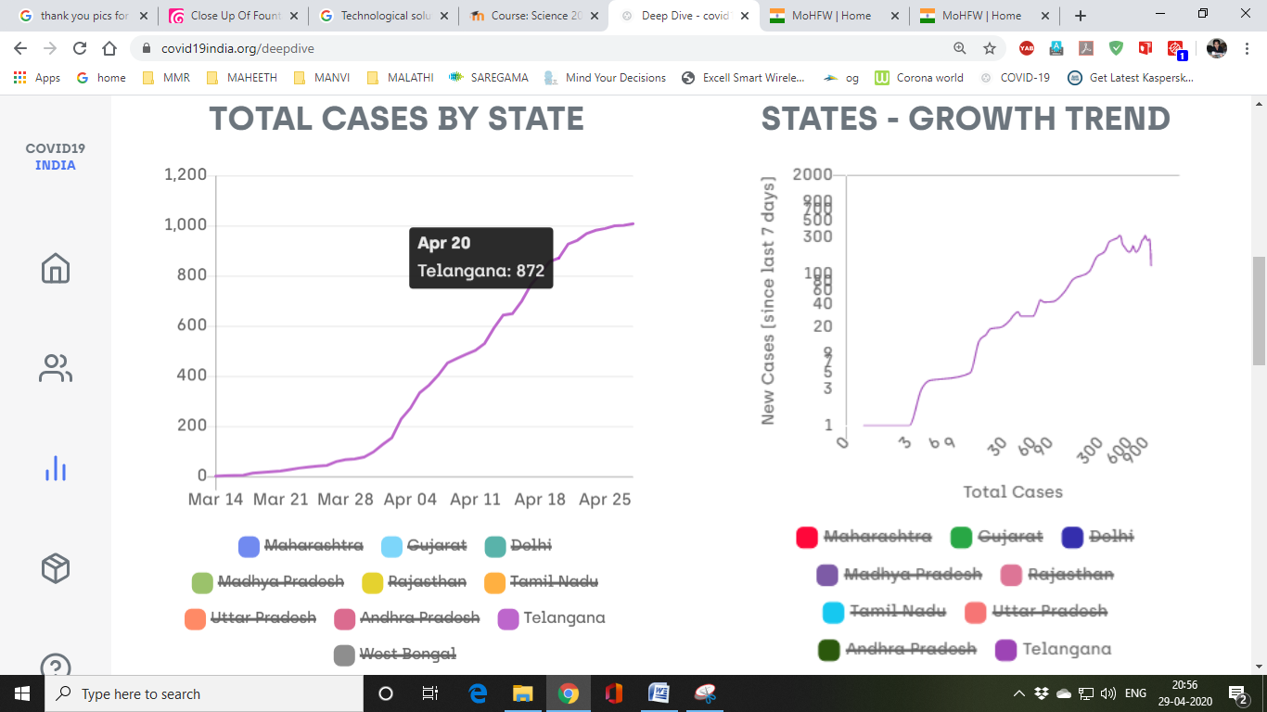

Graph showing number of COVID **cases reported from 14th-20th of April 2020** in Telangana State. This gives an idea about **Growth Trend of reported cases** in the State

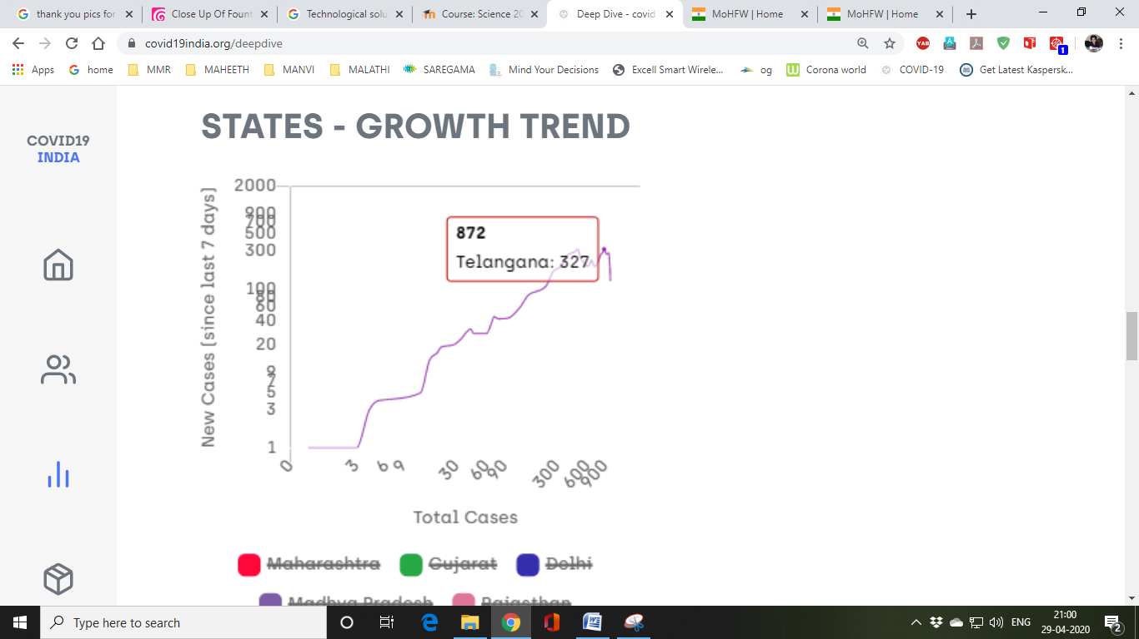

Source: <https://www.covid19india.org/>

**Interview of a recovered COVID-19 Patient**

**Note:** Because no COVID-19 cases were reported in my neighbourhood, I chose to write an interview of a patient who had recovered after being tested COVID positive

**Patient Details:**

|  |  |
| --- | --- |
| **Name** | Akhil Ennamsetty |
| **Age** | 24 years |
| **Sex** | Male |
| **Religion** | Hindu |
| **Travel History** | Travelled from London to Hyderabad via Mumbai, by flight |
| **Other Details** | Law Student at University of Edinburgh, Scotland. Practicing in Warangal High Court |
| **Link to Interview** | <https://www.youtube.com/watch?v=mjLvG_OgL70&t=6s> |

**The Interview**

**Reporter**:

Today, we have a special guest who travelled to Hyderabad from abroad. He was suspicious about contracting the virus, and voluntarily went to the hospital to get himself tested. Though he was COVID positive, he has recovered now, and we are glad to have him as our guest today. Hello sir, we are glad that you have accepted for an interview with us.

**Akhil**: Hello sir and thank you for reaching out to me.

**Reporter:** What made you return to India from Scotland?

**Akhil:** Britain decided to go for a country-wide lockdown lately. By that time, India already announced that it wouldn’t allow any flights from UK or Europe from March 18. Luckily, my parents managed to get me a flight ticket for March 17. Most of my Indian friends are still stranded in Britain.

**Reporter:** Why did you feel you might have contracted the disease?

**Akhil:** By the time I landed at RGI Airport in Hyderabad, some of my friends messaged me that they were tested to be positive at their home countries. So, I felt I might have contracted COVID. I also had a mild sore throat after my arrival. After speaking to the airport helpdesk, I decided to go to Gandhi Hospital the next day. I checked into a nearby hotel and tried my best to avoid contaminating the space.

**Reporter:** How do you rate treatment given to you in the hospital?

**Akhil:** The way we were treated in the hospital was excellent. The isolation wards are well maintained, with plenty of light and good ventilation. They daily changed the bed sheets and hazmat suits. The wards were kept clean. We were given packed food for breakfast, lunch and dinner along with packaged drinking water. To enhance our immunity, we were given dry fruits also. The treatment given to each patient was based on the symptoms we showed. The doctors checked us daily after breakfast. On the whole, I appreciate their efforts.

**Reporter:** How did you spend your time in the hospital?

**Akhil:** The hospital provided us free Wi-Fi facility. I was able to attend online classes through my phone. I also spoke to my friends and family over video calls. My days were never boring, thanks to the hospital administration.

**Reporter:** What message do you give to the people?

**Akhil:** I strongly recommend people to follow self-isolation and not go out during this pandemic unnecessarily. It is our social responsibility to maintain social distancing. Those who feel they are showing any symptoms should voluntarily get themselves tested. Because, if they don’t, they may end up infecting their near and dear ones, and in the worst case, they might lose them too. A person should not be afraid of what the society would say if he/she is tested to be positive. I would encourage those who have been recovered like me to donate their blood plasma for research purposes.

**Reporter:** What are your suggestions to the government in controlling the pandemic?

**Akhil:** In the long run, thermal screening may not be effective. I cleared thermal screening at airport but I was tested to be positive. I urge the government to perform Swab Test on every person arriving in the country. If he is tested negative, warn him to be in self-quarantine, otherwise give him treatment. It is easy to break the chain if this can be done. No virus is first identified in India, it can only be brought by travelers coming from abroad. I appreciate the efforts they are putting in already, but what I said is more effective.